EXPT NO:4 | Visual encoding of data
DATE: 20.01.2026 | Visual encoding of data

PRE-LAB QUESTIONS
- How does the human visual system process visual variables?
The human visual system quickly interprets visual variables such as color, size, shape, and position, enabling fast pattern recognition and comparison.

- Why is improper encoding misleading in analytics?
Improper encoding can distort perception, hide critical insights, and lead to incorrect conclusions and decisions.

- What are perceptual limitations in visualization?
Humans have limited ability to distinguish similar colors, small size differences, and complex visual patterns in dense data.

- How does color choice affect interpretation?
Color influences attention and meaning; poor choices can confuse users, while good choices improve clarity and understanding.

- Why should AI dashboards be perceptually optimized?
Perceptually optimized dashboards reduce cognitive load, improve trust, and ensure correct interpretation of AI insights.

OBJECTIVE: To apply effective visual encoding principles for meaningful data communication.

SCENARIO: A city traffic department analyzes accident data to identify high-risk zones and accident severity patterns.

IN-LAB TASKS (Using R Language) • Encode severity using color gradients • Represent accident frequency using size • Use shape to indicate accident type

CODE:
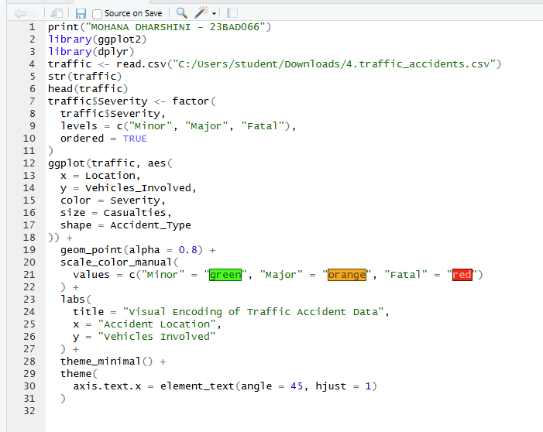

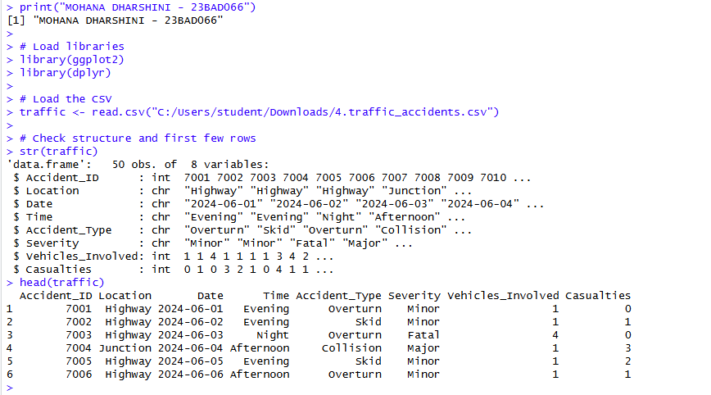

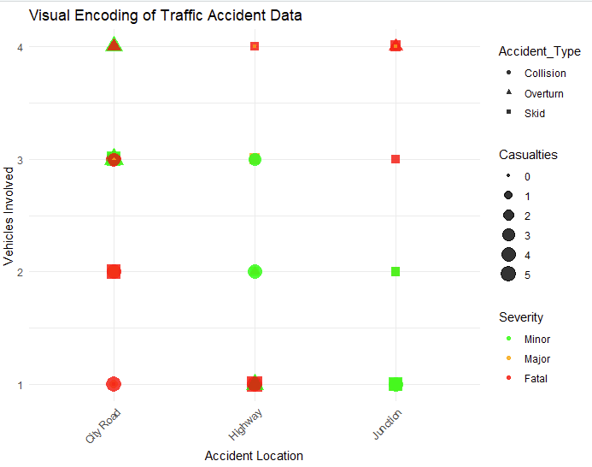
POST-LAB QUESTIONS

- Which visual variable best conveys severity and why?
Color best conveys severity because it is immediately noticeable and intuitively associated with danger levels.

- How can poor encoding mislead policy decisions?
Poor encoding may hide high-risk zones or exaggerate minor issues, leading to ineffective or unsafe policy actions.

- What precautions should be taken for color-blind users?
Use color-blind-safe palettes, combine color with size or shape, and avoid relying on color alone.

- How does visual encoding affect AI explainability?
Effective encoding makes AI results more interpretable and transparent, improving user trust and understanding.

- Suggest improvements for large-scale public dashboards.
Interactive filters, simplified visuals, accessible color schemes, and responsive layouts improve usability.

LEARNING OUTCOME: Students learn perceptually effective visual communication for AI systems.

ASSESSMENT
Description | Max Marks | Marks Awarded
Pre Lab Exercise | 5
In Lab Exercise | 10
Post Lab Exercise | 5
Viva | 10
Total | 30
Faculty Signature

